**VARIABLES**

**AND**

**DATA TYPES**

SARTHAK SANAY

**(1) AIM:-**

To practice declaring and initializing variables of different data types in C.

**CODE:-**

**#include <stdio.h>**

**int main()**

**{**

**// Integer variables**

**int i = 42;**

**short shortI = 32767; // Short integer**

**long longI = 1234567890L; // Long integer**

**// Floating-point variables**

**float f = 3.14f;**

**double d = 2.71828; // Double-precision floating-point**

**// Character variables**

**char c = 'A';**

**// String variables**

**char str[100] = "Sarthak Sanay";**

**// Printing the values**

**printf("Integer Variable: %d\n", i);**

**printf("Short Variable: %d\n", shortI);**

**printf("Long Variable: %ld\n", longI);**

**printf("Float Variable: %.2f\n", f);**

**printf("Double Variable: %.5f\n", d);**

**printf("Character Variable: %c\n", c);**

**printf("String Variable: %s\n", str);**

**return 0;**

**}**

**OUTPUT SCREEN:-**

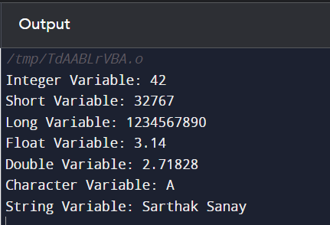

**P.T.O.**

**(2) AIM:-**

To implement a program in C to perform Arithmetic operations (addition, subtraction, multiplication, division, etc.) on variables.

**CODE:-**

**#include <stdio.h>**

**int main()**

**{**

**int a=10, b=5, sum, diff, prod;**

**float quotient;**

**// Performing the Arithmetic operations**

**sum= a+b; // Addition**

**diff= a-b; // Subtraction**

**prod= a*b; // Multiplication**

**quotient= (float)a/b; // Division**

**// Printing the results**

**printf("Sum is: %d\n", sum);**

**printf("Difference is: %d\n", diff);**

**printf("Product is: %d\n", prod);**

**printf("Quotient is: %d\n", quotient);**

**return 0;**

**}**

**OUTPUT SCREEN:-**

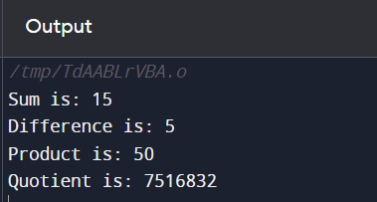

**(3) AIM:-**

To experiment with typecasting in C.

1. Implicit typecasting
2. Explicit typecasting
3. Typecasting with different data types
4. Typecasting with arithmetic operators

**CODE 1:- (Implicit Typecasting)**

**// Program in C to demonstrate Implicit Typecasting (Widening Conversion)**

**#include <stdio.h>**

**int main()**

**{ int a= 10;**

**float b= 5.5;**

**// Implicit typecasting (widening conversion)**

**float res= a+b;**

**printf("Sum using Implicit Typecasting: %.2f\n", res);**

**return 0;**

**}**

**OUTPUT SCREEN 1:-**

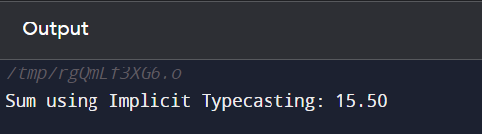

**CODE 2:- (Explicit Typecasting)**

**// Program in C to demonstrate explicit typecasting (narrowing conversion)**

**#include <stdio.h>**

**int main()**

**{**

**int a;**

**float b = 5.5;**

**// Explicit typecasting (narrowing conversion)**

**a = (int)b;**

**printf("Explicit Typecasting: %d\n", a);**

**return 0;**

**}**

**OUTPUT SCREEN 2:-**

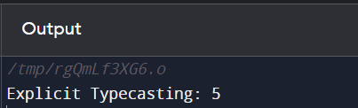

**P.T.O.**

**CODE 3:- (Typecasting between different data types)**

**// Program in C to Explicit typecasting between different data types**

**#include <stdio.h>**

**int main()**

**{**

**char c= 'A';**

**int n;**

**// Explicit typecasting from char to int**

**n = (int)c;**

**printf("Typecasting character '%c' to int: %d\n",c, n);**

**return 0;**

**}**

**OUTPUT SCREEN 3:-**

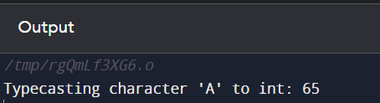

**P.T.O.**

**CODE 4:- (Typecasting with arithmetic operators)**

**// Program in C to demonstrate typecasting with arithmetic operators**

**#include <stdio.h>**

**int main()**

**{**

**int a = 10;**

**float b = 5.5;**

**// Typecasting with arithmetic operators**

**float res = (float)a/b;**

**printf("Typecasting with Arithmetic Operators: %.2f\n", res);**

**return 0;**

**}**

**OUTPUT SCREEN 4:-**

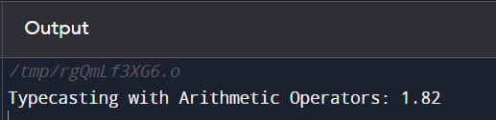

**P.T.O.**

**(4) AIM:-**

To write a program in C to convert temperature from Fahrenheit to Celsius and vice versa.

**CODE:-**

**// To write a program in C to convert temperature from Fahrenheit to Celsius and vice versa.**

**#include <stdio.h>**

**int main()**

**{**

**int ch;**

**float c, f;**

**printf("Enter 1 to input temperature in Celsius\nEnter 2 to input temperature in Fahrenheit\n");**

**scanf("%d", &ch);**

**if(ch==1)**

**{**

**printf("Enter temp in Celsius: ");**

**scanf("%f", &c);**

**f = (c * 1.8) + 32;**

**printf("%.2f C is equal to %.2f F", c, f);**

**}**

**else if(ch==2)**

**{**

**printf("Enter temp in Fahrenheit: ");**

**scanf("%f", &f);**

**c = (f-32) * 0.56;**

**printf("%.2f F is equal to %.2f C", f, c);**

**}**

**else**

**printf("Enter correct input for choice.");**

**return 0;**

**OUTPUT SCREEN:-**



